Behavior Intervention Policies and Practices
The mission of Telos is to create inspiring interpersonal relationships that invite and assist all people to move towards their ultimate potential. All students come to Telos with unhealthy behavior patterns. To promote real healing, we help students change these patterns.
At Telos we strive to inspire and invite change – not force it. While many behavioral tenants are true (for example, most people seek pleasure and avoid pain), behaviorism cannot be the beginning and end of the change process that occurs here. We are not training animals to do what we want them to do. At Telos we seek to guide human beings along the path of healing and greater functionality. Remembering this helps us avoid the tendency to jump to the consequence without considering the student, the behavior, the lesson, the student’s heart, how he will best learn, etc.
Telos employs a good number of standardized interventions to help assist students change their negative behaviors and promote positive healthy habits. All staff are trained regularly on these interventions and situations in which to use them. Some are reward based, some support based, and some consequence based. Standardized interventions are used across the board for all students at Telos.
Some of our standardized interventions include:
The Telos Relationship Continuum: The Telos relationship continuum is a standard approach that is addressed in monthly trainings. It outlines how to help students problem solve based on their behavior. The goal is for students to stay in the green, which represents a healthy headspace. Below is the Telos Relationship continuum chart. Each of the areas mean the following:
- Collaborative approach: when a student initially encounters a problem and is still in control emotionally. Staff should use a reflective listening pattern, reflect and validate a student’s feelings, and seek for win/win solutions to problems.
- Supportive approach: to be used with students who are reasonable, flexible, and showing only mild/medium distress. The consultant pattern should be used (listed below), as well as the processing approach (the process approach includes using black and white reasoning, breaking things down for the student, using an 80/20 compromise, etc.)
- Authoritative approach: for students who are irrational, oppositional, in high distress and are inciting others. Staff should always use neutral tones, stay 4 feet away from student and have their body at a 45 degree angle so as not to be threatening. Staff should give one clear redirect and set a boundary as a choice, for example: “You can lower your voice or leave class for a break in the hallway.” Students in the yellow may redirect to green or continue to escalate.
- Crisis Prevention: Student may be a danger to others, danger to self and/or a major disruption. This is when the authoritative approach has failed. Staff may employ some, or all of the following: call a supervisor, remove peers to a safe area, and consider a staff-switch out. The supervisor may call a support team, and may initiate an elbow lead or therapeutic hold. *See below for definitions of support team, elbow lead, and therapeutic holds.
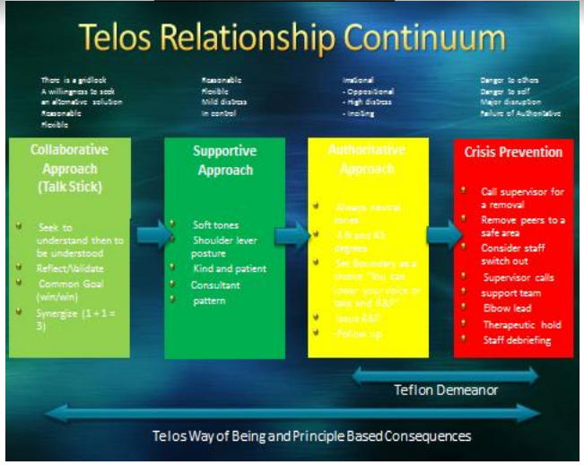

The Consultant Pattern: A problem solving strategy that involves staff helping students work through problems. Each member of the staff is given a card with the following script to remind them of the steps to guide helping students through a healthy problem solving approach. They are encouraged to put the script into their own words while still following the pattern.
- “Wow. You sound______. What happened?”
- “What are your options?”
- “Can I share what other kids in the situation have tried?”
- “What are you going to do?”
- “Why don’t you take five minutes to relax and make your decision? You’re a smart guy, I bet you’ll figure something good out.”
- “This puts me in an awkward situation….”
- Follow up: “That was a hard morning shift. Just want you to know I am still your friend.”

Forecasting: A teacher or staff member sets expectations and/or notifies a student of changes before they occur.
Prompting: asking a student to stop a certain behavior or to engage in a behavior.
Reflect and Process (R&P): a student is given an opportunity to take a break and process through an issue with a staff or teacher by problem solving and setting expectations. This processing employs the use of the consultant pattern.
Communication Block: a student loses his voice with a peer or set of peers as a consequence for inappropriate behavior.
10ft Rule: a student is not allowed within 10 feet of another student because of an inappropriate behavior.
Staff Buddy: a student remains within arm’s length of a staff member because he is being inappropriate or he needs coaching.
Standing Group: a student or a staff call a standing group because the floor needs to redirect or a student needs to express himself.
Line of Sight (LOS): a student is not allowed out of the staff’s sight.
Support Team Member/Staff Switch Out: a student is not working well with his designated staff members, a new staff member enters the scene as a neutral party to remove the student so problem solving can occur.
Support Team: a support team is called because the student’s intensity has increased and the student needs increased support. This intervention is designed to deescalate the student and to make sure correct procedures occur if a therapeutic hold is used.
Therapeutic Holds: an intervention designed to keep the student safe. A physical hold is administered because the student has acted out aggressively. **See the section on therapeutic holds for more information.
Elbow Lead: A staff gently takes a student by the elbow to lead them away from a high intensity situation. Any use of an elbow lead must be documented with an incident report form. *See end of document for sample form.
Removing the Student from the Stimulus: staff remove the students to a safe area when a peer is acting-out.
Community/Morning Groups: these groups are designed to problem solve and decompress each unit of boys on a daily basis.
Emotional Safety Groups: these groups are designed to explore the emotional climate on the unit.
Honor Roll Incentives Activity: Students who maintain a 3.5 GPA or higher and have positive citizenship grades earn entrance to a school-wide incentive activity for each quarter.
Flex Hour: Students are given an hour each school day with access to one-on-one teacher support to catch up on missing or misunderstood school work. An academic advisor assigns students as needed.
Safety Watch: Designed for students who have demonstrated harmful behaviors towards themselves or others, or who are a risk for running from the program. Students are given a red t-shirt to wear (so they will be easily identifiable to staff) and are required to remain within an arms-length of staff at all times. Students who are as risk for harmful behaviors may shut, but not latch, the bathroom door when using the restroom. Two staff will remain outside the bathroom while the student is alone inside.
Staff Shadow: A step down from safety, for students who are earning trust back after a larger incident. Students are given a bracelet to wear, and must remain within staff line of sight at all times, except for when in the bathroom. These students are allowed to close and lock bathroom doors.
The Mindfulness Center: A physical room within the building that is designed for students who need to practice mindfulness techniques in order to reduce stress. This may be used as part of an R&P so that a student can decompress before processing through a problem.
General Instructional Support: Telos has developed an RTI model for supporting students academically within the school environment. These 3 tiers of support are designed to reduce stress and promote academic success and functioning. All students are given access to tier 1 supports, and tier 2 and 3 are implemented on an as needed basis. See pyramid below:
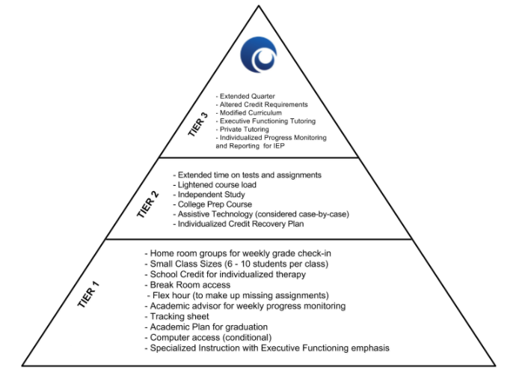

Specialty Protocols
At times there are students who do not respond to the standard Telos interventions. When this occurs, the student’s treatment team meets to discuss formulating a special protocol for that student. Because specialized protocols are taxing on staff, there is an effort to use them only for high need cases. The team uses a number of types of protocols, including the following:
Moral Compass: Many students who have processing deficits need tactile interventions. This intervention is designed to help students learn the value of living a principled-based life. Good choices are reinforced and poor choices lead to accountability and teaching moments. This intervention helps the student remember his goals each hour of the day. A member of the treatment team assists the student in making a compass out of wood. The compass is painted on each side. One side is painted darker than the other. The darker side represents all of the unhealthy traits the student came into telos with, and the lighter side represents the principles the student is trying to incorporate. Both sides of the compass should be labeled. Once made, the student begins to wear the compass around his neck. When a staff notices the student is succumbing to his unhealthy traits, the compass is flipped to the dark side and the student takes an R&P. He thinks about how the trait affects him. A processing worksheet (developed by his therapist) can be used to help the student think through his behavior. (The worksheet should ask questions like: what did I do that got me on an R&P, what was driving me on the dark side of the compass? What do I need to practice on the light side of the compass? What will stop me from practicing it? How will the dark side of my compass affect others in the future?) Staff should process with the student after the R&P. The amount of weekly flips of the compass can be measured and connected to a long-term treatment plan goal. The student should receive a decreased number of flips over a period of time. If the flips are not decreasing from week to week, the intervention should be reassessed. Example: Dark side of the compass may be labeled: compulsive, mean spirited, oppositional. The Light side may be labeled: In control, kind, cooperative.
Scales: This intervention helps the student know where he is currently and what he needs to achieve. The scale allows the student to visually picture his goal and serves as a measuring tool on a daily basis. It also allows the staff to give consistent focused feedback from shift to shift. The scale can measure anything the team decides the student to work on. It should use simple language and not measure too many things at once. Once the scale is created, the staff can give the student daily scores, thus assessing how well the student functioned according to the scale. The scale should be attached to a treatment plan goal. The scale should be posted on the unit for everyone to see. If needed, the scale should be used in the classes the student attends. Example of a scale for Resiliency: 1-3 on the scale – student avoids, fakes illness, hides behind excuses; 4-6 on the scale: - does something unwillingly, bad attitude, complaining; 7-10 on the scale – willing, no complaints, pushes himself despite difficulty, shows investment. At the end of a shift a student’s behavior is scaled and a score recorded in a journal. The student should achieve higher averages on the scale from week to week.
Solo: This protocol 1) allows for an overstimulated student to settle into less rigid thinking and a calmer emotional state, 2) creates discomfort for a student who is comfortable in his dysfunction, 3) provides a predictable consequence for students who can’t yet respond to insight-based interventions, and 4) provides a consistent system of accountability for students accustomed to chaos and poor structure. To set up the protocol the treatment team defines clear behaviors that trigger the protocol. Staff are instructed to direct the student to a location where he can sit away from the group for a predetermined period of time. Following the solo, staff process the triggering event in an effort to create a learning moment with the student. A few guiding principles that should be observed with this protocol: 1)staff must not implement this protocol in a spirit of revenge or punishment, 2) the use of this protocol must originate at a lead/director/therapist level, 3)students must be allowed reasonable restroom breaks and cannot be denied meals or medical attention, 4) if the protocol is attempting to address items 2 or 4 (from above), staff should avoid allowing students to take their solo in a setting that could reinforce the undesired behavior (such as their beds). Most times taking the solo in a standard chair is appropriate. 5) a single solo episode should not exceed two hours unless directed by the treatment team. 6) If staff are concerned that this protocol is overused or not used appropriately, it should be reviewed immediately by the therapist and in the next treatment team.
Dice: The dice protocol is designed to help a student understand the value of trust and honesty. If a student is showing that he cannot be trusted, then the staff stops taking what he says as truth. If the student makes a request then a dice is rolled and the dice decide the student’s fate. The dice can also be rolled at set times throughout the day deciding the student’s status for the remainder of a shift. The team decides what each number on the dice should represent. At the beginning of the intervention the dice should be heavily stacked against the student. The odds should move towards the student’s favor as he demonstrates he can be trusted. Over time the student should be showing signs of honesty and trust. Example of a Dice protocol: Roll a 1 or 2: you are on line of sight with staff, 3 or 4: You will lose your check-outs for the day. 5 or 6: you may have what you requested.
Stop Light: The purpose of this intervention is to condition a student’s decision making abilities and to help students have foresight. It reinforces healthy coping skills and holds the student accountable for maladaptive coping. It is processing friendly in as much as it keeps the student’s world ‘black and white.’ When a student shows his typical maladaptive behaviors, he is in the yellow zone. He has a choice while in the yellow zone to redirect in a healthy way, which would move him into the green zone. He can also choose not to redirect, which, would move him into the red zone. The green zone can be defined in any way and so can the red zone. The student must see the green zone as favorable and the red as less favorable. There should be a significant decrease in the intensity and frequency of the acting out within about four to six weeks. Within the first few weeks expect to see little improvement as the staff and student adapt to the intervention. Example: When Frank is rude, challenges authority, and is argumentative he is in the yellow zone. He has two choices at this time: go to the red one or move back into the green zone. The Green Zone: Frank takes a break under staff direction without complaint. The break lasts 10-15 minutes, during which time he can engage in self soothing behaviors. After the time allotted, he process with a staff and owns what he has down and apologize to any person he has hurt. Redirecting to the green zone will earn him points that will allow him to access phone calls to approved friends on the weekend. The Red Zone: Frank refuses to take the green zone option and continues to be rude, challenging authority and arguing. Frank is asked to go to the break room for 45 minutes. If he needs a support team to take him there, he will be required to stay there for 90 minutes. If a support team needs to place him in a hold, then he will also be placed on safety status. He will need to have two good shifts to come off of safety status. The quality of those shifts are determined by the therapist and lead.
Ace Cards: The ace card intervention is aimed at ego defense mechanisms, but is not limited to targeting such behaviors. The purpose is to heighten the student’s awareness regarding his process rather than getting stuck in his content. This intervention has a CBT background as it highlights thinking errors. The therapist first educates the student about his maladaptive process that gets in the students’ way when navigating through life. The common ego defenses include: blame-shifting, deflecting, avoidance, procrastination, minimizing, denial and justifying. Once the therapist has helped the student understand his defenses, he creates laminated cards that the student is required to wear (on a lanyard around his neck or in his pocket) to highlight the defenses in the milieu. When the defenses surface in the milieu the staff can then bring them to the students attention by pulling the relevant ace card and using the moment to teach and redirect. The therapist should attach the number of ace card pulls to the student’s treatment plan. Depending on the number of pulls, a student can receive predetermined rewards or consequences. The ace card goal should be set once a baseline is understood by the team. Over time the student should see a decrease in ego defense behaviors.

Consequences Policy:
Occasionally a student may need a consequence for breaking a rule. In these situations, staff are given autonomy to create a principled consequence. These types of consequences can be applied frequently, and differ from protocols. A consequence is a one-time response from a staff member for an isolated behavior. Protocols are interventions that address a larger cluster of behaviors (such as the student being stuck in his treatment progress.)
To issue a principled consequence a staff follows the following steps:
- Identify the principle the student violated (e.g., respect, tolerance, care, honestly, etc.)
- Think of a task the student can perform that will teach the principle violated.
- Determine if the task is something the student will likely “get” or understand.
- Communicate the consequence to the student and record it on HQ.
- Follow up to assure the student has completed the task.
Example: A student swears at a teacher. He has violated the principle of respect. After contemplation a staff may ask him to interview his three favorite staff and three favorite students and ask them when they have felt the most disrespected and how it impacted them, they may then require them to report what they learned in community meeting. The staff will follow up the next day to make sure the student completed the task.

Therapeutic Holds:

Definitions:

Brief Hold: A brief hold is any approved, time-limited restraint lasting less than 30 minutes.
Sustained Restraint: A sustained restraint is a time-limited restraint lasting longer than 30 minutes. It must be approved by a therapist or the clinical director at the 30 minute mark. The sustained restraint must be approved by the medical director if it lasts longer than 60 minutes.

Brief holds and sustained restraints at Telos include only physical restraint for the student’s safety and are always body-to-body. Other restraining devices like strait jackets, tie downs, locked rooms, or sedatives are never allowed at Telos. Brief holds and sustained restraints at Telos are limited to situations of safety and are to be carried out in safe and respectful ways.

If a student is assessed to need seclusion or multiple brief holds or multiple sustained restraints (as defined by the treatment team on an individual basis), then the treatment team will call an appropriateness of fit staffing to decide on the student’s appropriateness for treatment at Telos.

In order to certify to carry out brief holds and sustained restraints, staff attend a training workshop run by a member of the Telos Leadership team. They are taught de-escalation techniques, and practice the proper holds and procedures during the training workshop. Staff are required to renew this training yearly.

Brief hold and sustained restraint policies and procedures:

- Brief holds and sustained restraints should only be used as a last resort.

- Brief holds and sustained restraints should only be used for assessed risk to self or others and not as behavioral punishments or behavioral management tools.

- Safety holds are justifiable if a student demonstrates risk to self or others and has not responded to a verbal redirect. Risk to self-type of behaviors can include (but are not limited to) cutting, head banging, ingesting dangerous substances, picking, pulling hair, suicide attempts, etc. Risk to others may include, throwing objects, punching, scratching, hitting, etc.)

- Before using a brief hold or sustained restraint, the clear criteria contained in these procedures must be met.

- Only employees who have been trained in current Telos procedures concerning brief holds and sustained restraints may carry out the procedures. All staff will be retrained on an annual basis.

- When deciding which brief hold or sustained restraint technique will be used, employees should always choose the least restrictive methods.

- Whenever a brief hold or a sustained restraint is implemented, the primary therapist or clinical director must call and inform the parents.

- When brief hold or sustained restraint procedures are enacted, careful measure should be taken to protect the rights, dignity, and well-being of the student. If the student needs to be separated from other students, employees should use nurturing language, inform the student of all actions, pay respectful attention to clothing and body parts, and never deprive the student of physical essentials.

- When a brief hold or sustained restraint is used, an extra staff should be monitoring the situation to ensure that proper technique is followed at all time.

- Staff should be trained in early detection of potential risks during brief hold and sustained restraint procedures.

- If staff is alone with a student, they may not engage the student in any type of hold unless there is an imminent danger to life.

- An incident report form must be filled out for each brief hold and sustained restraint, and the employees who participated in each should engage in a “debriefing” with their immediate supervisor.

10. Approved methods of brief holding and sustained restraining:
A. Side-body
B. One arm
C. Two-arm
D. Two-person
E. Two person Floor Control with no leg restraint

Blank example of an incident report:
Incident Report | Last Modified: Never

Incident/Discipline Report
Incident Report Guidelines
- Always write the Incident Report and have it sent out during your current shift
- Be detailed in your notes. Do not assume anything when writing. It is important that we paint a clear picture of what took place.
- Use first name and last initial of all persons involved (including observers and those that responded but were sent away after sufficient staffing was reached).
- Make sure to keep time when a hold occurs and check in with the proper people at the proper times when needed (i.e. Therapist, Psychatrist, Clinical Director, etc.)
- ALWAYS have a debrief meeting to discuss the incident. This is used for several reasons:
  - To get on the same page when writing the incident report to ensure all stories match and are accurate
  - To discuss what went well and what needed improvement
  - To discuss whether proper technique was used
  - It’s a training opportunity for the Campus Supervisor
  - To ensure that all parties are taken care of physically and emotionally
All Incident Reports must include:
- Who was involved in the incident
- The nature of the incident
- If a hold occurs, we need to state there was an observer
- What type of hold occurred: Bear hug, half basket, full basket, two man hold, floor two man hold
- When the debriefing occurred
Example:
I, staff Jaren H., responded to a support team call at approximately 8:45 pm. The support team was called to the Fuji common room. When I arrived staff Nate H. was processing with student Brandon F. who appeared to be escalated AEB pulling on his hair and screaming “Leave me the Fuck alone!” Shortly after I arrived, staff Derek M. and staff Brady C. came in to support. Nate H. asked the student if he would like to take a walk with any of the staff present. Once Nate H. asked this question, student Brandon F. screamed “I’m going to kill you!” and moved toward staff Nate H. in an aggressive manner. Staff Derek M. and Brady C. approached student Brandon F. from behind and placed him in the 2-man standing hold. I, Jaren H., observed the hold and attempted to calm the student by sitting on the ground near him and helping the student focus on his breathing. Staff Nate H. recorded the time. After approximately 2 minutes student Brandon F. committed to being safe and staff Derek M. and Brady C. released the hold. Student then processed with staff Nate H. and apologized for his behavior. I, staff Jaren H., led a debrief meeting at 10:00 pm to discuss this incident will all involved.
INCIDENT REPORT
Reported by |  | Krystal Jensen
Date of incident
Time of incident
Name(s) of staff involved
Location of incident
Incident type
Did this incident require a Physical Escort, Brief Hold, Sustained Restraint?  PHYSICAL ESCORT: Using contact to move a student, BRIEF HOLD: "Restraint" lasting less than 30 minutes, SUSTAINED RESTRAINT: "Restraint" lasting 30 minutes or more. |  | Physical Escort  Brief Hold  Sustained Restraint  None
Hold/Restraint Start Time
Hold/Restraint End Time
Therapist or Clinical Director notified at 30-minutes?
At 30 minutes, the student's therapist (or Clinical Director if therapist is unreachable) must be notified to receive a verbal order to continue.
Description of incident
Actions taken/consequences
Actions completed: |  | Staff signature
Date report was reviewed by member of management:

